CUSTOMER CHURN PREDICTION

**1. Introduction**

In this work, we aim to analyze survey data to gain insights into the customer. Our study uses IBM Cognos and focuses on comparing the standard deviation and accuracy of the data. Our findings will help us understand trends, changes and potential relationships.

**2. Data creation**

The survey dataset was uploaded to IBM Cognos, and data cleaning was performed to check for missing values or outliers. The dataset includes information on cases and deaths.

**3. Data visualization**

* **Comparison of mean values**

Bar charts were generated to compare the number of people in telecommunication (e.g. region, etc.).

* **Standard deviation comparison**

Box plots were used to visualize the distribution of customer and gender , highlighting medians, quartiles, and potential extremes.

* **Long-term trends**

The graph was used to track trends in incidence and age of the people, allowing us to track the evolution of the epidemic.

* **Communication analysis**

Linear plots were constructed to examine possible relationships between population size . Correlation coefficients were calculated to quantify these relationships.

**4. Research and analysis Trends**

We observed significant variability in customer. Correlation: Our study shows a strong positive association between population size and associated customer. This relationship underscores the importance of timely preventive and therapeutic interventions.

PROJECT REPORT: CUSTOMER CHURN PREDICTION

**DATA VISUALIZATION AND ANALYSIS**

1. Number of people using telecommunication

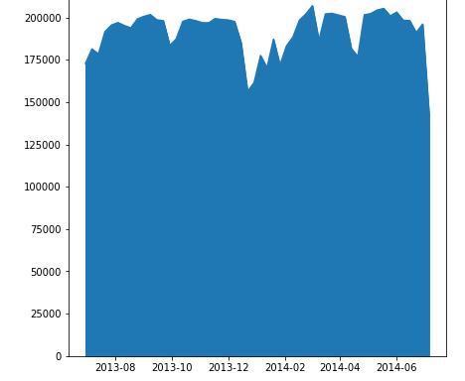

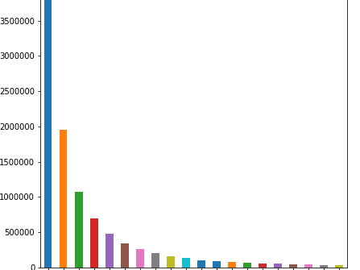

PROJECT REPORT: CUSTOMER CHURN PREDICTION

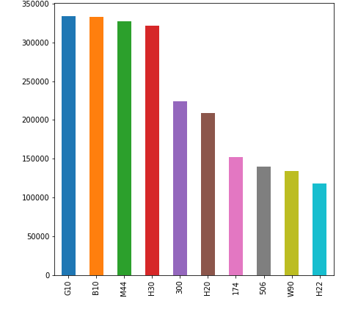

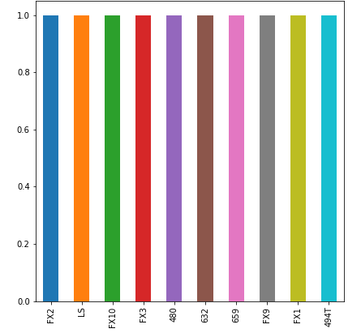

PROJECT REPORT: CUSTOMER CHURN PREDICTION

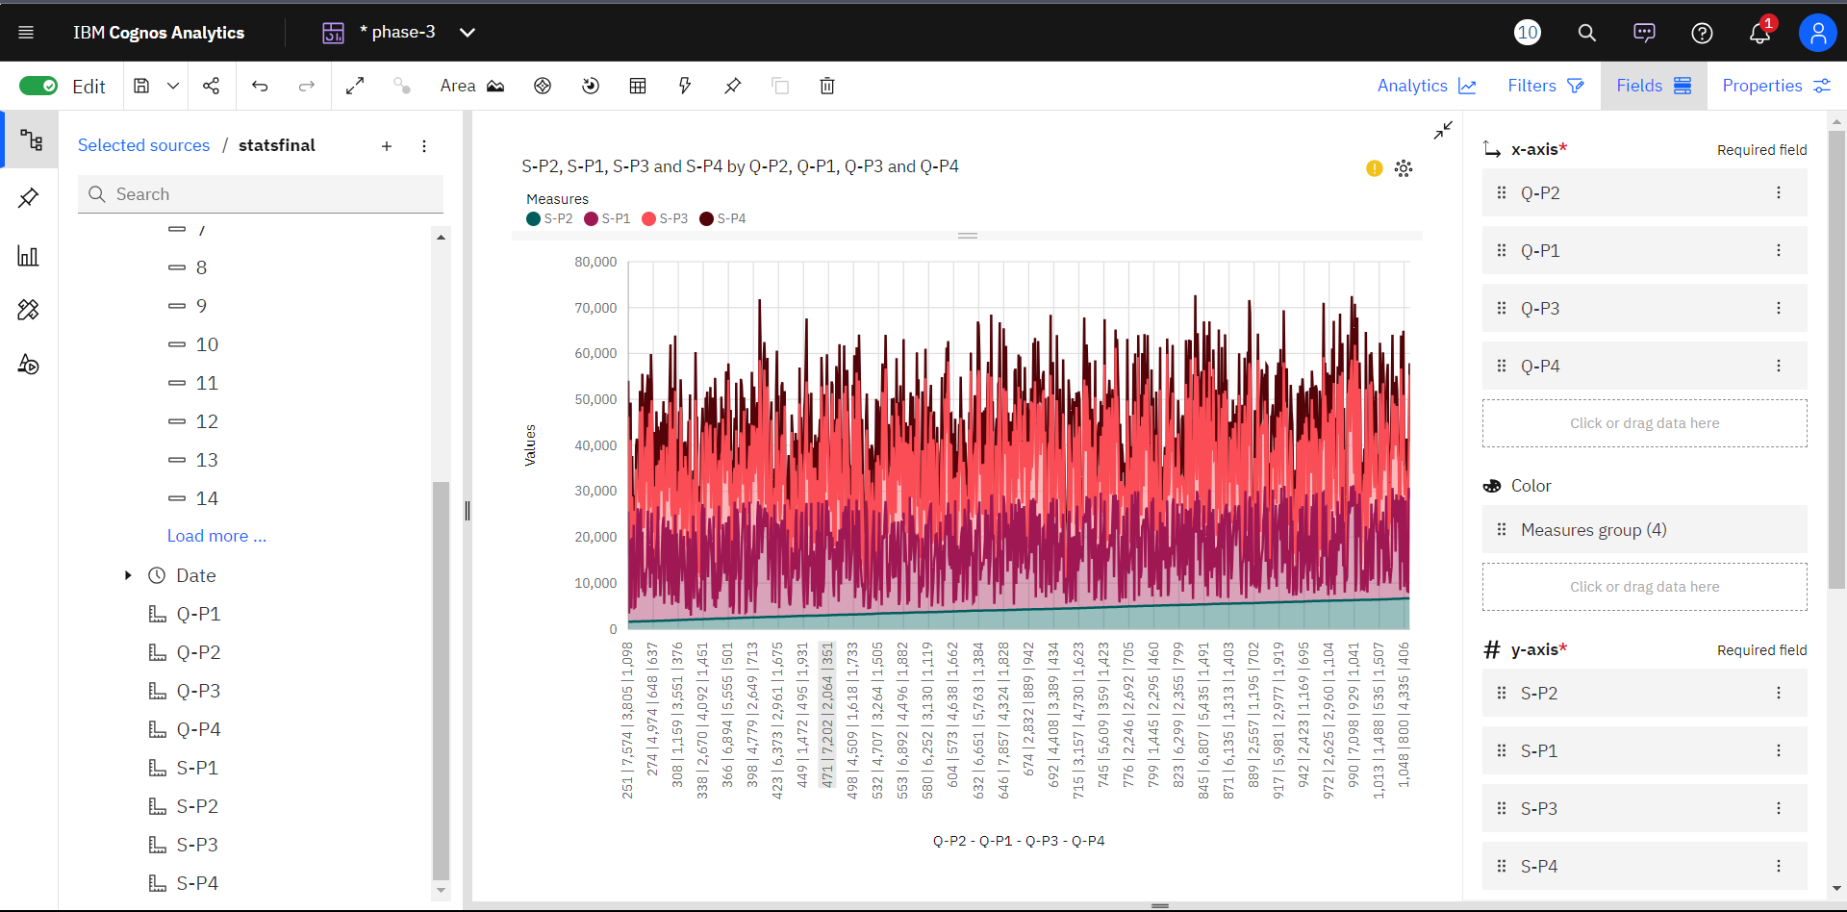

**5. Conclusions**

The project data analysis using IBM Cognos provided valuable insights into the customer churn prediction. Trends and changes were identified, providing potential areas for targeted intervention. Correlation analysis emphasizes the importance of measures to customer.

